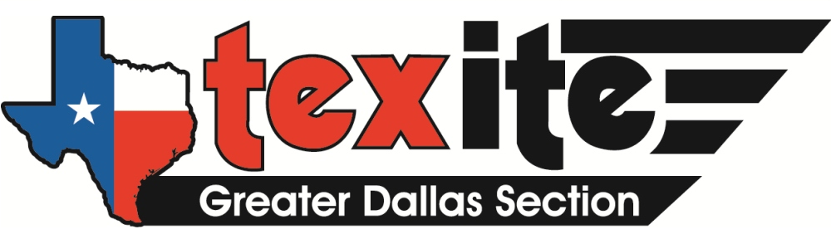

Scholarship

2018 - 2019 TexITE Dallas Scholarship
The Greater Dallas Section of ITE is an organization dedicated to transportation engineering in the Greater Dallas Area. The Dallas Section is part of the Texas District of ITE, known as TexITE. The Greater Dallas Section is pleased to announce 2018 scholarship eligibility requirements and deadlines.
You can download all available information at:
http://dallas.texite.org/scholarship

Deadline: E-Mailed or Postmarked no later than Friday, July 20th, 2018

Scholarship Awards: One or more (non-renewable) scholarships for one academic year. Minimum award amount of $1,000 per winner. Higher amounts may be awarded at the discretion of the Board based on funding availability.

Degree Program: Registered as a full-time student in an undergraduate (Sophomore/Junior/Senior level) or postgraduate STEM (Science, Technology, Engineering, Mathematics) program at an accredited university. Preference will be given to applicants enrolled in at least one Traffic/Transportation Engineering or Transportation Planning related class.

Questions: Contact Joseph Marchione at (214) 670-3182 or joseph.marchione@dallascityhall.com

The winners of the 2017 - 2018 scholarships were:
- Allison Cline, Texas A&M University - $2,000
- Mynor Jacome, Texas Tech University - $1,500
- Sheida Khademi, University of Texas at Arlington - $1,500
- Connie Xavier, Texas A&M University - $1,000

